**CAT Grade 12: Additional Practical Activities**

*CAT is constantly evolving and for this reason we have decided to provide you with additional practical activities. These activities include topics and skills that have been tested in recent DBE question papers, but that are not all covered in the current text books.*

*For additional practice we have added some questions which have not been asked before, but which are also not covered in the text books – just to give you extra practice with such questions. You will find that if you think carefully, and READ the dialog boxes, you can usually work out for yourself how to answer them. Fortunately, these types of questions, which test skills that are perhaps less often used, make up a very small percentage of an exam paper. Look at the mark allocation during your practical examination and DO NOT waste time with such questions if you find them more difficult – FIRST complete those questions that test skills with which you are familiar!*

*The following activities are not based on any specific theme, as one would expect in a proper question paper; and fortunately a proper question paper does not consist only of these types of questions!*

**Activity 1 – Word processing**

Open the document **Line Numbers**.

1.1 Change the line numbers in the left margin to appear as follows:

* The line numbers must start at 10.
* Only every second line number must be displayed.
* The numbering must restart on each page.

Save and close the document **Line Numbers**.

Open the document **Responsible Use** (and use this document for the rest of Activity 1).

1.2 Change the Table of Contents on page 1 as follows:

1.2.1 The TOC must display page numbers instead of hyperlinks on a web page. (Assume that the document will be saved later as a single file web page file for viewing in a web browser.)

1.2.2 Remove the heading ‘Responsible use of computers’ from the table of contents, but without removing the heading from the body of the document.

Ensure that the formatting of the heading remains as Arial 24 pt Bold, paragraph ‘after’ spacing 12 pt.

1.2.3 Change the scale of the character spacing of the TOC to 110%.

1.3 Add a shadowed paragraph border to the paragraph in red under the heading ‘Introduction’. The border must be 5 pt from the text on all 4 sides.

1.4 Create a new label called ‘Image’ and add the caption ‘*Image 1: Computer viruses are bad news!*’ above the picture under the heading ‘Computer viruses’.

1.5 Add the screen tip ‘Not used anymore’ to the hyperlink on page 2.

1.6 Insert the picture ‘Computer’ as a watermark only on page 3.

1.7 Set the absolute position of the image under the heading ‘Internet access’ to 6 cm below the top margin of the page.

1.8 Locate the text ‘callmore time’ under the heading ‘Internet access’ on page 3.

Change the footnote to this text that reads ‘Telkom deal’, so that the footnote appears below the text on the page, and not at the bottom of the page.

Also change the number format to  .

1.9 Locate the text ‘Computer Use’ under the heading ‘Switching off the computer’.

Create a hyperlink on this text that points to the bookmark ‘ComputerUse’ in the file **Green Computing**.

1.10 Locate the text ‘The cost of running a computer ... referring to <<>>’ under the heading ‘Switching off the computer’.

Replace the blue placeholder <<>> with a cross reference to the equation on the last page of the document.

Include only the caption text as a cross reference.

1.11 Add a text border to the text in blue ‘Paper and ink cost money!’ under the heading ‘Computer equipment and other media’.

1.12 Locate the line under the text ‘Number of times...’.

Replace this line with a red 2 pt horizontal line that is 10 cm wide, and centred across the page under the text.

1.13 Change the font colour of all instances of the whole word ‘computer’ (case sensitive) to green.

Enter the number of times the whole word ‘computer’ (case sensitive) appears in the document, in the red text box on page 4.

1.14 Add an Editor (metadata) property to the document, using your own name as the value.

1.15 Locate the fields and place holders near the bottom of page 4.

1.15.1 Locate the form field next to the text ‘School name’.

Add help text that will display ‘Enter the name of your school’ when the F1 key is pressed.

Add default text to this form field that reads ‘ABC High’.

1.15.2 Replace the yellow place holder next to the text ‘Document created by’ with the Author field.

1.15.3 Set the default value of the check box field next to the text ‘Spelling check performed’ to not checked.

1.15.4 Replace the green place holder next to the text ‘Total number of words in document’ with a field that displays the total number of words in the document.

1.16 Locate the shape near the bottom of page 4.

Use the fill feature to fill the shape with the **Computer** picture.

1.17 Locate the equation on the last page of the document. A part of the equation has been left out.

Refer to the following equation and add the part that was left out from the equation in the document:

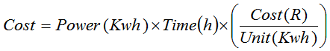

1.18 Mark all instances of the word ‘electricity’ as entries for an index.

1.19 Now insert an automatic index, with right-aligned page numbers, on the last page of the document. Use the default settings.

Save and close the document **Responsible Use**.

**Activity 2 – Word processing (conditional mail merge)**

Open the document **Letter to parents** and perform the following conditional mail merge:

2.1 Replace the place holders with the corresponding fields in the source spreadsheet **Registration**.

Use an If...Then...Else mail merge rule to replace the He/She place holder with text based on the *Gender* field name. If the value of the field is *Male*, the text ‘He’ must be inserted, otherwise the text ‘She’ must be inserted.

Save the document **Letter to parents** just before you complete the merge.

2.2 Complete the mail merge, by merging only records 2–7, and save the merged document with the name **Letter to parents MERGED**.

Save and close both the documents.

**Activity 3 – Spreadsheet**

Open the spreadsheet **Cellphone Users**. Work in the **Data** worksheet.

3.1 Insert a comment in cell C2 that reads ‘Check cellphone number’.

3.2 The dates of birth of the users are stored in column D.

Use a function in cell F3 to display the number of the birth month of Sheree Leverington.

3.3 Use an appropriate lookup function in cell G5 to determine the service provider of Ryan Nase.

Note that the first three digits of the cellphone number represent the service provider.

The lookup table required is stored in the **Service Providers** worksheet.

3.4 Use a formula in cell I8 to calculate Sinikwe Hoyi’s age in 2016 (i.e. how many years old she will be on her birthday in 2016).

3.5 Use a spreadsheet feature to force the user to enter a valid cellphone number (i.e. one that contains exactly 10 digits/characters) in column C.

Add a suitable error message that the user will receive if he/she tries to enter invalid data.

*Hint:* Use Data Validation.

3.6 Use conditional formatting to automatically apply the ‘3 Flags’ icon set format style on all the values in column H.

Use the following categories:

* Red flag: >= 750
* Yellow flag: 400 – 749
* Red flag: 0 – 399

3.7 Use conditional formatting to automatically apply a 2-colour scale format style on all the values in column I (Age in 2016).

Change the colours of the minimum and maximum values as follows:

* Minimum (lowest value): green
* Maximum (highest value): blue

3.8 Locate the chart **Average data used (MB) per age group** and do the following:

* Remove only the Primary Minor Horizontal gridlines.
* Insert a linear trend line.

Your chart should appear as follows:

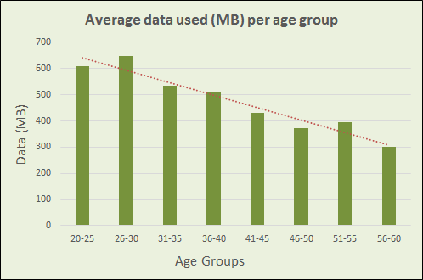

3.9 Locate the chart **Gender distribution per age group** and do the following:

* Remove the Blank series (there must only be two series, i.e. Males and Females).
* Change the ‘Females’ data series to display as clustered columns, similar to the ‘Males’ data series.

Your chart should appear as follows:

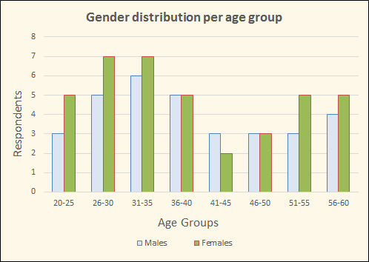

3.10 Locate the pie chart **Sample Group** and do the following:

* Change the chart to a Doughnut chart.
* The doughnut hole size must be 30%.
* The chart must have any 3-D bevel effect.
* Show the Leader Lines that connect each data label to its slice.

Your chart should appear similar to the following:

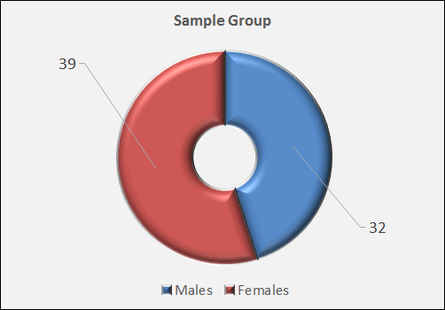

3.11 Filter the data so that those who do not have a cell phone number in the worksheet are not displayed.

Save and close the spreadsheet.

**Activity 4 – Database**

Open the database **ArtExhibition**.

4.1 Make the following changes to the design of the **Applications** table:

4.1.1 Change a field property of the **CellNo** field so that the user is forced to enter data in this field AND to accept no duplicates. Do NOT change the primary key. Ignore any warning messages that may appear.

4.1.2 Change a field property of the **Exhibition** field to display check boxes instead of Yes/No.

4.2 Create a query called **Summary** based on the **Applications** table that will display the total amount raised per school per category, as shown in the table below.

*Hint:* Use the **Totals** command in the **Design** tab, and *aggregate functions*.

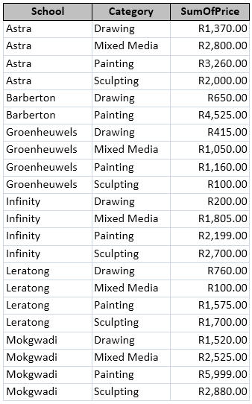

4.3 Import the data of the **Contacts** worksheet of the **School Contact Persons** spreadsheet as a linked table into the database. Use the same name as the spreadsheet worksheet for the table.

4.4 Set the properties of the form **Entry Form** so that users will not be able to delete any data.

4.5 A report **SchoolCategories** has been created. The records have been grouped according to the **School** field.

* Base the report on the **Categories** query.
* Ensure that each school starts on a new page.

Close the database.

**Activity 5 – HTML**

Open the web page **Table Practice** in a browser and also in a text editor.

Use the **COLSPAN** and **ROWSPAN** attributes to make the green and blue tables appear as shown below.

*Note: These two attributes are used to merge cells in a table, as in Word and Excel. COLSPAN merges rows, and ROWSPAN merges columns (the reverse of what you might expect). Study the HTML code carefully before you make any changes.*

The GREEN table should look like this:

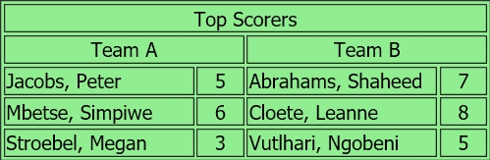

The BLUE table should look like this:

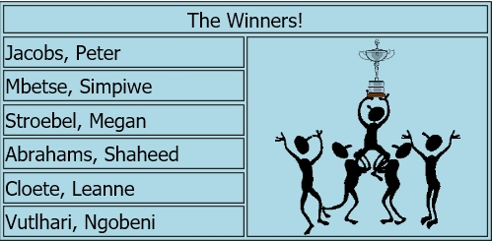

Save and close the web page.

**Activity 6 – General**

Extract the file from the **LionLove** compressed file to your exam folder.